Parent Meeting 10-18-2S2
Call to order
Julie Mossing went over the secretary’s report. Rita Randall approved it. Sherri Cavada seconded it.
Kelly Arlia went over the minutes from the parent meeting last month. Erin Grabowski approved it. Liz Shermeto seconded it.
PTDG T-shirts and online store
Design for the shirt has been sent to Fancy Fox. We are aiming for the end of the week of 10-24 for the online store to open. Once open, we will send out the link and encourage every parent (especially volunteers) to buy a shirt to promote the show and to wear at shows so people can identify those part of the parent volunteers. The store will offer short sleeve shirts, long sleeve, crew neck sweatshirts, and hoodies. Also, the PTDG shirts will be available. The pricing for the shirts is listed here:
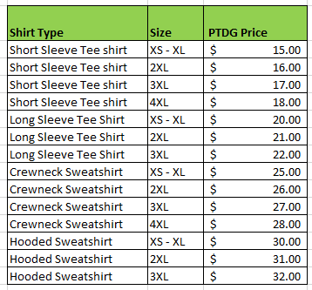

Jen Haberberger’s report on how the production was coming along and overall is good. Attendance is still an issue.
The videos for the dances in the show will be posted so the kids can practice at home. Mia Confer is chorographer now and it is going well. With 3 of our stage managers graduating, we will be on the lookout for new ones.
The junior and seniors took a trip to Seton Hill to see Pippin, but also to take a tour of the school on Thursday, October 20. The rehearsal schedule will be modified in order the students to be able to go.
There is also a trip to PMT (Pittsburgh Musical Theater) to see the Little Mermaid on November 3rd. There will most likely be cost for this and more details to follow.
If you don’t have clearances yet and plan on volunteering, please get them done ASAP!
Costumes are coming along great.
Sets are starting on Wednesday 10-19.
Painting will hold their first meeting on Thursday, 10-20 at the back of the auditorium.
Props are coming along slowly but surely.
Hair and Makeup is getting everything ready.

Parent Committees
Half price tickets for volunteers. Tickets are $7 at the door, but for those parents that are volunteering at any show has the opportunity to get tickets for half price for setting in a section towards the back. If a parent wishes to sit with family, they may purchase a ticket at regular price.
Publicity – Erin Grabowski
We will have enough signs for each student in the cast and crew to get one. Please be mindful where you place it because the purpose to promote the show so it will be best in a high traffic area.
Sign Gypsies donated a yard sign for the Nutcracker like they did for Fiddler.
Recapped the HOCO parade.
Trunk or Treat is Thursday, 10-27 and we have everything we need to get our show featured. Thanks to all who have helped.

Gift Table – Still need volunteers to make things and volunteers on show day.
Fundraising – Sherri and Corey Cavada have already made an amazing start in getting giftcards and food donated from local businesses. We are going to decide how we are going to use these items ie raffle and use it to feed the kids.
PT Pizza in Level Green has generously donated lunch for the students – pizza and salads.
We will be doing segments during the Make – A – Wish Telethon in December.
Photography – Stacey Hasley will take the head shots and candid shots during tech week. She can even go earlier to get some pictures for the gift table.
Concession Stand – Rita Randall No real updates. We will be selling cookies, water, hot pretzels and candy at the shows. We are always accepting donations for candy. Sams Club has the big bars.
50/50 Raffle - No updates
Chaperones/Security – No new updates
Ushers – Christine Goldsworthy. Students from CAP are the bulk of the help so they get community service hours

New Business
Activity fee is overdue
Online store will open soon. Watch for an email with a link.
Donations are still being accepted for water and candy
Join Remind group for updates.
Cast Party will be held December 3 and we need a volunteer who will hold it at their home.
Adjournment Motion Erin Grabowski and seconded Rita Randall

